Abstract Title
First Author (First name and Surname)¹, Second Author ², ******³, Corresponding Author^{1,*}
¹ First Author’s Affiliation, City, postal code number, Country
² Second Author’s Affiliation, City, postal code number, Country
³ ******
* Corresponding author (Tel: xxx; E-mail: xx@yy.zz)
This document gives formatting instructions for authors preparing abstract for 2018 China-Japan-Korea Symposium on Analytical Chemistry (2018 CJK). The authors must follow the instructions given in this document. The lines of text should be single spaced, with an additional half line space before each paragraph. Two characters should be retracted at the very beginning of the paragraph. The length should be limited to one page.
The title should be in 14-pt Arial Font in bold. Author names should be in 10.5-pt Times New Roman. The affiliation and mailing address should be in 9-pt Times New Roman. The rest of the text should be in 10.5-pt Times New Roman. Put an asterisk (*) after the corresponding author (e-mail is compulsory for the corresponding author). The heading of the title, author name and affiliation should be with only the initial letters capitalized. Center justified the title, author names and affiliations.
Please supply the MS Word documents.
References numbers for citations after the abstract should be put in square brackets [X].
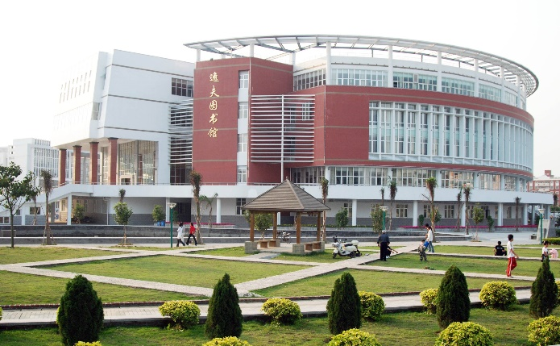
Fig. 1 Set captions in 9-pt Times New Roman in bold, and center the caption and the figure. Figures should be arranged in parallel if there are more than two figures. The picture height should be limited to less than 6 cm.
Keywords: 3-5 words with the initial letters capitalized; separate each words with a semicolon; 10.5-pt Times New Roman
References
[1] Author (surname), A.; Author, B.; Author, C.; et al. Journal Name 00 (Year) 000-999.
[2] Zhang, S.; Li, S.; Zhou, W.; et al. Talanta 108 (2013) 117-122.
[3] ……

