Requirements and templates for CJK-2018 Poster

1. Preparation for the Poster

The Poster needs to be displayed in the prescribed size as far as possible. 90 cm (wide) *120 cm (high) is required for the CJK 2018. To make your poster more attractive, you need to design a poster in person (recommend using Windows PowerPoint for design, refer to the wall newspaper templates 1 and 2 we provide). Color print and bring it to the meeting scene in person.

2. Posting

During the meeting, you need to put up your posters at the Poster site provided by the organizing committee. The meeting will provide you with the necessary tools (tape, tacks, etc.). At the same time, it is necessary for you to do a good job of communication, warm reception of every colleague, and carefully answer all kinds of questions. This will be a good idea for you to enlighten academic ideas and establish academic contacts. In addition, you can prepare your name cards for contact.

3. Best Poster Award

Your poster is likely to win the award of CJK 2018 best Wall Award at the current meeting, which will be presented at the closing ceremony of the conference.

Warm tip: after the Poster show is finished, you need to take your own poster and pay attention to the safety and tidiness of the site and facilities.

Model 1 Model 2
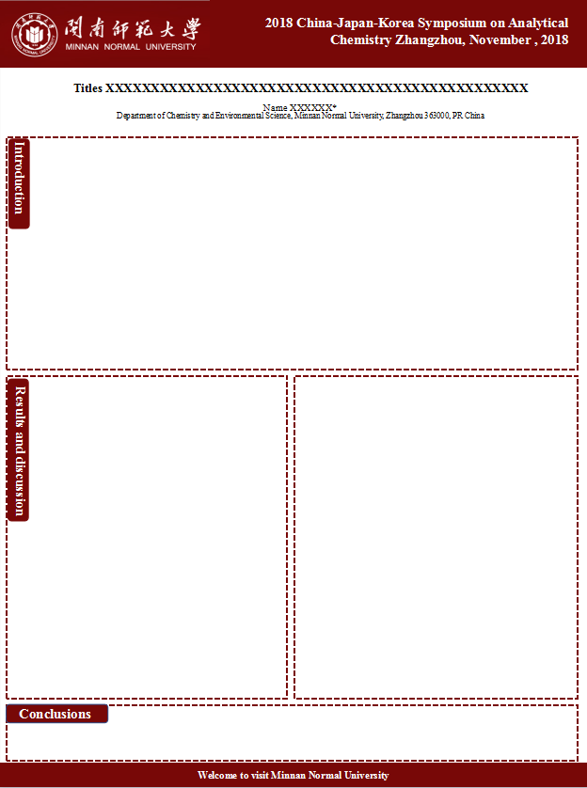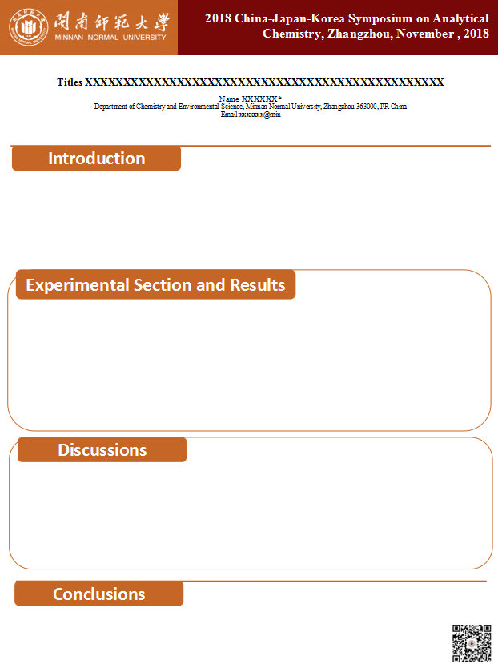

墙报要求及模版
在本届CJK会议上，墙报（Poster）展示是另一种非常重要的学术交流方式。
1. 墙报的准备
墙报需要在规定的尺寸内，将您的研究成果尽可能的进行展示。本届年会墙报的规定尺寸是：90cm（宽）*120cm（高）。为使您的海报更具有吸引力，需要您亲自设计墙报（推荐使用Windows PowerPoint进行设计，可参考我们提供的墙报模板1和2），将其彩色打印，并亲自带到会议现场。
2. 张贴墙报
会议期间，您需要在规定的时间，到组委会提供的Poster场地张贴您的海报，会务会为您提供必要的工具（胶带、图钉等）。同时，需要您做好交流的准备，热情接待每一位同行，细致解答各种疑问，这将是您启发学术思想，建立学术联系的大好机会。此外，可准备一些名片以便联系。
3. 最佳墙报奖
您的墙报有可能获得本届会议设立的“2018CJK最佳墙报奖”， 届时将在会议闭幕式上进行颁奖。
温馨提示：在墙报展示结束后，需要您亲自取下自己的墙报，并注意维护场地和设施的安全和整洁。
模板1 模板2

